# Task 1:

**In the header division, in the right corner, add three icons [1. fb 2. twitter 3. Instagram]**

**[Feature to be used - absolute positioning]**

**if mouse is hoverer over the images, it should be scaled.**

**Added three icons – normal mode.**

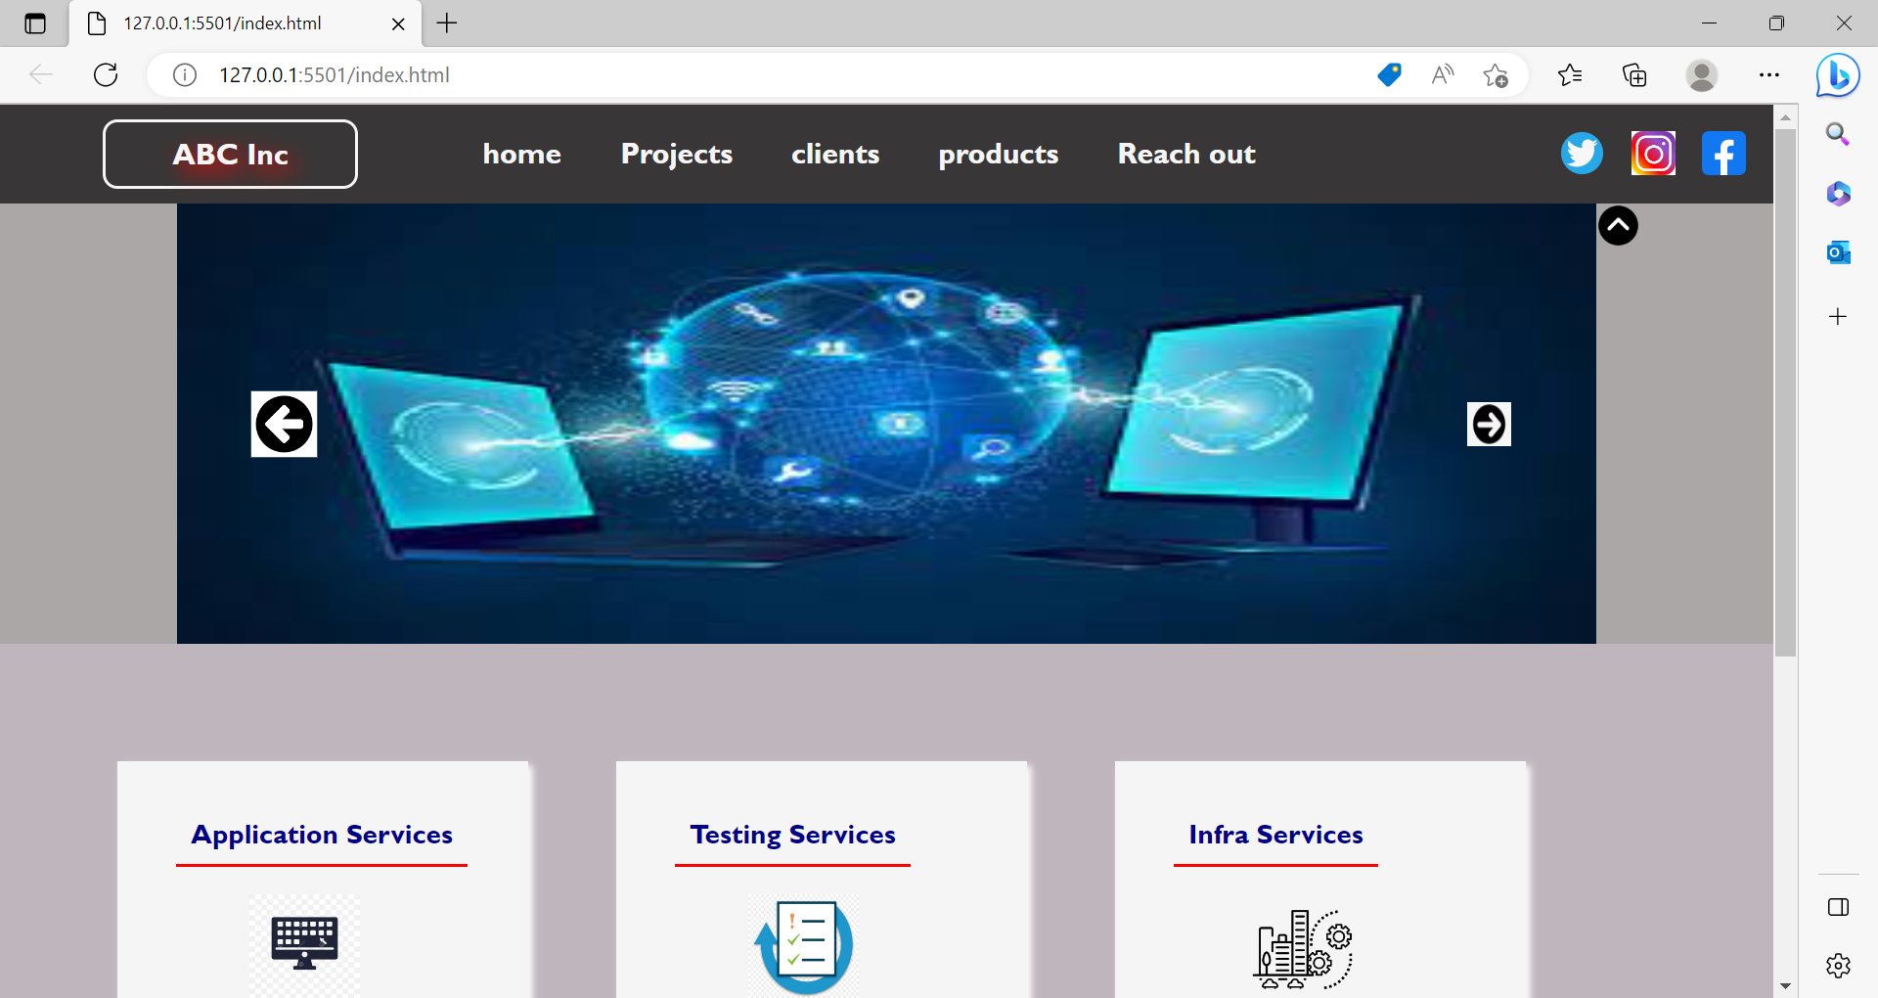

**Facebook icon mouse over – scaled mode.**

**Instagram icon mouse over – scaled mode.**

**Twitter icon mouse over – scaled mode.**

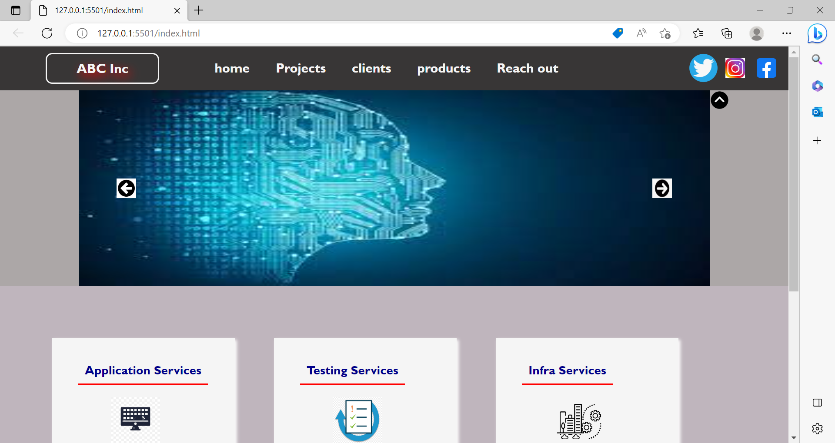

# Task 2:

**now in the service-box division, the features list item is not showing clickable cursor/pointer**

**1. make it show pointer and clickable**

**2. if clicked we must call a function and the function should alert the content of current li (note: pass this as parameter to function)**

**Show pointer and clickable.**

**Service name alert message**

# Task 3:

**now in the service-box image if you take mouse over it the image must move right-side by 50px and when you take away mouse pointer it should go back to original positioning.**

**[note: explore transform: translate]**

**Infra Service Image mouse over**

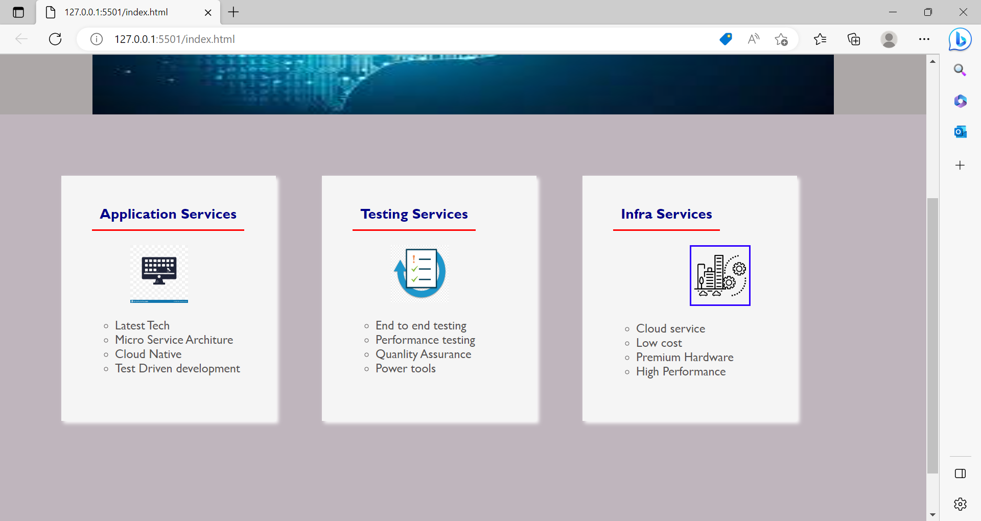

**Take away the mouse from Infra Service Image – Original position.**

# Task 4:

**now in the slide-area, top right corner put double up arrow icon, if you click it the slideshow must be hidden, and the up arrow must be changed to down arrow if down arrow is clicked again slide show must be visible and down arrow should be converted to up arrow.**

**Normal – up arrow display in right hand side corner**

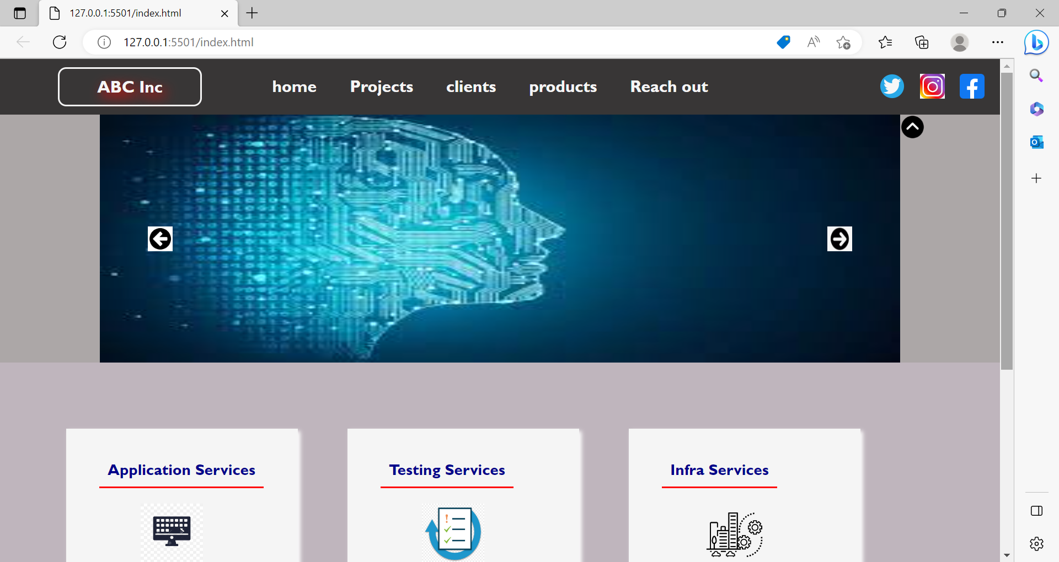

**After up arrow click – slide show hidden and down arrow display.**

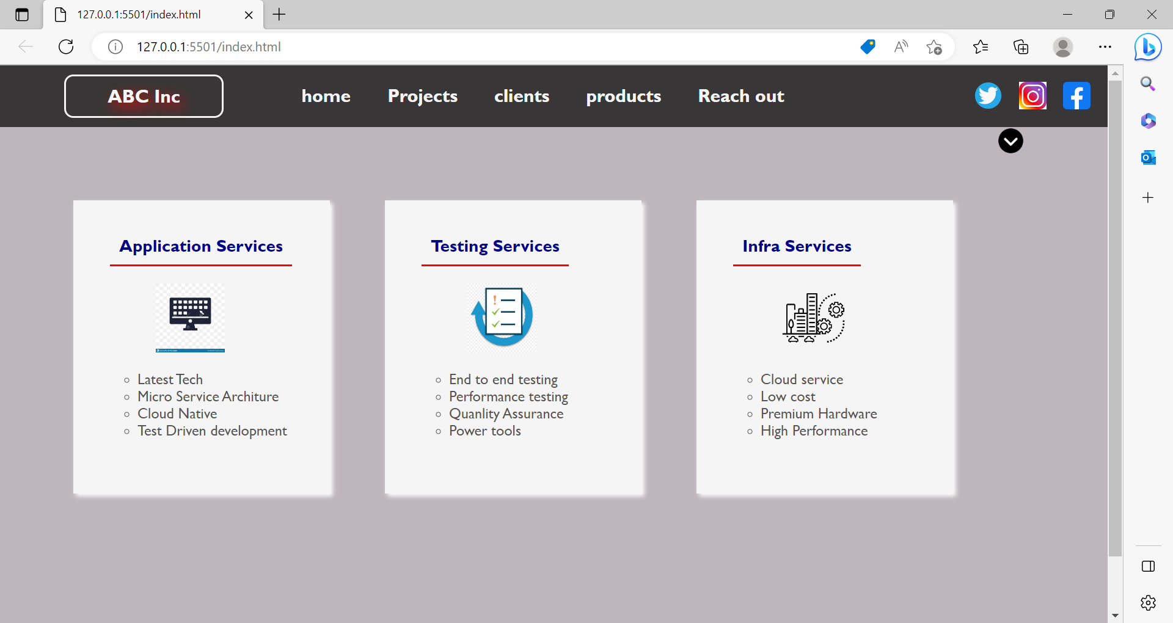

**After down arrow click – slide show display and up arrow display.**

